Step 1:- Open Chrome or any other browser.
Step 2:- Search github on browser.
Step 3:- Open first link in browser and sign in to github account if have or create github account by
signup in it.
Step 4:- Now, after sign up in github account you have to create a repositories as shown in below
image.
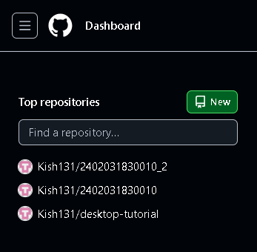
Click on new button as shown in image.
Step 5:-
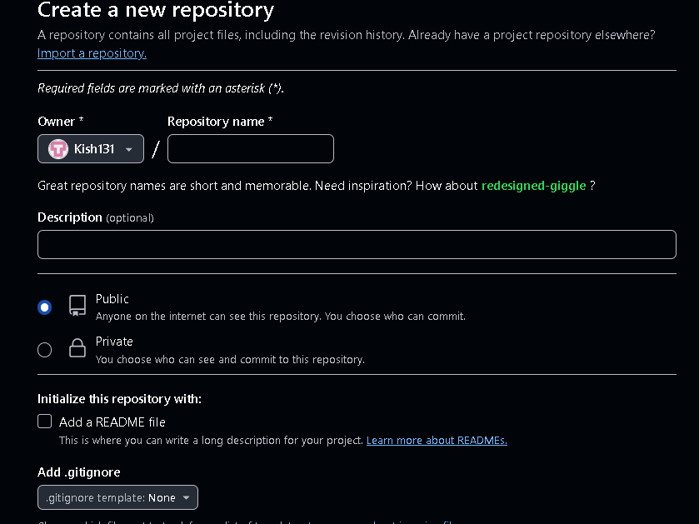
Give name to your repository and click on create button as shown in below image.
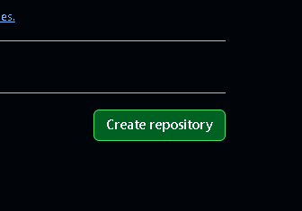
Now, your repository is created .
Step 6:- create two folders in your repository named as Assignment 1 and Assignment 2.

